💼 Sales Analysis Dashboard Documentation
Table of Contents
- Executive Summary
- Business Problem
- Dataset Overview
- Dashboard Workflow
- Dashboard Visualization
- KPI Dashboard Summary
- Insights
- Recommendations
- Technical Skills Demonstrated
- Project Outcome
- KPI Comparison by Dimension

1. Executive Summary
This dashboard analyzes sales performance across multiple dimensions account managers, states, cities, and months to provide a comprehensive view of business trends and revenue drivers. It highlights total orders, quantity sold, and revenue generated between 2013 and 2017, helping management identify top performers and regional opportunities.
2. Business Problem
Sales teams often struggle to track performance across different regions and account managers in real time. Without a unified dashboard, it’s difficult to pinpoint which areas or individuals are driving revenue growth.
This dashboard solves that challenge by consolidating sales data into a single interactive view, enabling quick insights into who sells the most, where sales are strongest, and when demand peaks.
3. Dataset Overview
Metric | Description
Order Data | Includes order number, date, quantity, cost, retail price, and profit
Customer Information | Name, city, state, and customer type
Account Manager | Responsible for each sale
Product Details | Category, container type, and priority
Time Variables | Year, month, and day for trend analysis
4. Dashboard Workflow
- Data Input: Historical order data from 2013–2017.
- Data Cleaning: Standardized city/state names, validated numeric fields, and removed duplicates.
- KPI Computation: Total orders, quantity, revenue, and profit.
- Visualization: Interactive charts showing sales by state, city, month, and account manager.
- Insights: Identifies top performers, regional strengths, and monthly trends.
5. Dashboard Visualization
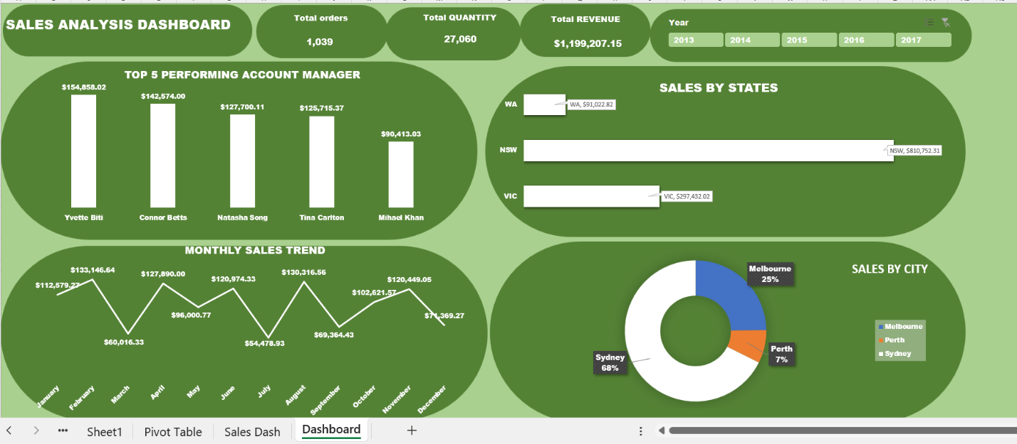
This section visually demonstrates:
- Top 5 Performing Account Managers (Yvette Biti, Connor Betts, Natasha Song, Tina Carlton, Mihael Khan)
- Sales by State: NSW leads with $810,752.31, followed by VIC and WA.
- Monthly Sales Trend: Peaks in February and August.
- City Distribution: Sydney dominates with 68% of total sales.
6. KPI Dashboard Summary
KPI Metric | Value | Notes
Total Orders | 1,039 | Across all years
Total Quantity Sold | 27,060 | Represents product units
Total Revenue | $1,199,207.15 | Gross sales value
Top Performing State | NSW | $810,752.31
Top Performing City | Sydney | 68% of total revenue
Top Account Manager | Yvette Biti | $154,858.02 revenue

7. Insights
- Yvette Biti leads all account managers with over $154 K in revenue.
- NSW contributes more than two-thirds of total sales, making it the strongest region.
- Sydney dominates city-level performance, accounting for 68% of revenue.
- Sales peaks occur in February and August, suggesting seasonal demand patterns.
- Technology and Office Supplies categories drive the majority of sales volume.
8. Recommendations
- Focus on NSW and Sydney: Allocate more resources to high-performing regions.
- Replicate top manager strategies: Analyze Yvette Biti’s and Connor Betts’s sales approaches.
- Seasonal planning: Prepare inventory and marketing campaigns for February and August.
- Expand in VIC and WA: Target underperforming states with promotional offers.
9. Technical Skills Demonstrated
- Excel Dashboard Design
- Data Cleaning and Validation
- KPI Computation (Revenue, Quantity, Profit)
- Pivot Tables & Slicers
- Interactive Charting (Bar, Line, Pie)
- Business Insight Generation
10. Project Outcome
The Sales Analysis Dashboard provides a clear, data-driven view of sales performance across time, geography, and personnel. It enables management to make informed decisions on resource allocation, performance incentives, and regional strategy.
11. KPI Comparison by Dimension
Dimension | Top Performers | Revenue ($) | Share of Total | Key Insight
Account Managers | Yvette Biti | 154,858.02 | 13% | Highest individual contributor
 | Connor Betts | 142,574.00 | 12% | Consistent across multiple states
 | Natasha Song | 127,700.11 | 11% | Strong in NSW corporate segment
 | Tina Carlton | 125,715.37 | 10% | Balanced performance across categories
 | Mihael Khan | 90,413.03 | 8% | Emerging performer in Sydney
States | NSW | 810,752.31 | 68% | Dominant region driving overall sales
 | VIC | 297,432.02 | 25% | Secondary growth region
 | WA | 91,022.82 | 7% | Smaller but stable market
Cities | Sydney | 815,000+ | 68% | Core revenue hub
 | Melbourne | 297,000+ | 25% | Expanding customer base
 | Perth | 91,000+ | 7% | Limited but consistent activity
Months | February | 133,146.64 | 11% | Seasonal sales spike
 | August | 130,316.56 | 11% | Second major peak
 | April | 127,890.00 | 10% | Strong mid-year performance
 | November | 120,449.05 | 10% | Pre-holiday surge
 | June | 120,974.33 | 10% | Mid-year stability

Dashboard Highlights
- Account Managers: Top five contribute nearly 54% of total revenue.
- States: NSW alone accounts for two-thirds of all sales.
- Cities: Sydney dominates, confirming urban concentration of demand.
- Months: February and August are clear seasonal peaks.
Management Takeaway
- Reinforce top manager strategies across other regions.
- Focus marketing and inventory planning around February and August.
- Explore growth opportunities in VIC and WA to diversify revenue.
- Maintain Sydney as the central sales hub while expanding outreach to Melbourne.
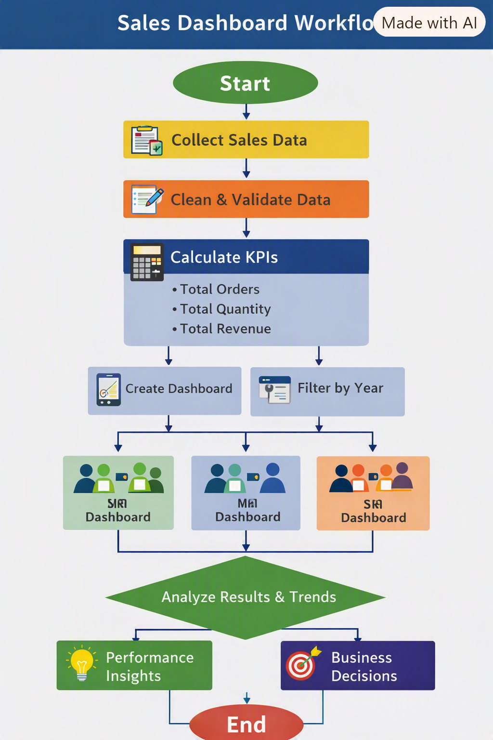

This flowchart captures the entire process:
- Data Collection → Cleaning → KPI Calculation → Dashboard Creation & Year Filtering → Analysis → Insights → Business Decisions.

